Advising Developmental Math
We offer two MTT 2 sessions (A and B) during the SPRING and FALL semesters and one MTT 2 session during SUMMER semester. Each session will last eight weeks. Your goal is to get the students in the correct number of MTT 2 sessions. The developmental math instructors will take over from there to ensure the students are working on the correct units.
STEP 1: Determine what units are needed for your student’s program of study. This can be found in the Advising Center under Developmental Requirements by Program. The link to the Advising Center is http://www.dcc.vccs.edu/advising/advising.html.
STEP 2: Determine which units your student has satisfied via the VPT or by taking a MTT course. This should be verified in SIS by using the Adv/StdGrp Tab within Student Inquiry. Advising folders are not a reliable source for this information as they are not typically up to date. Due to the nature of the VPT, units can be passed out of order. Do not be alarmed to see a student that has satisfied Unit 0 and Unit 2 but not Unit 1 as this is perfectly normal. Examples of how to interpret the Adv/StdGrp Tab as it pertains to developmental math are illustrated in Figure A and Figure B. Notice that “College Success” indicates that the student satisfied that math unit when they took the VPT and “Score Evaluation from Pearson” (or another variation) indicates that the student took and passed that unit during an MTT course.
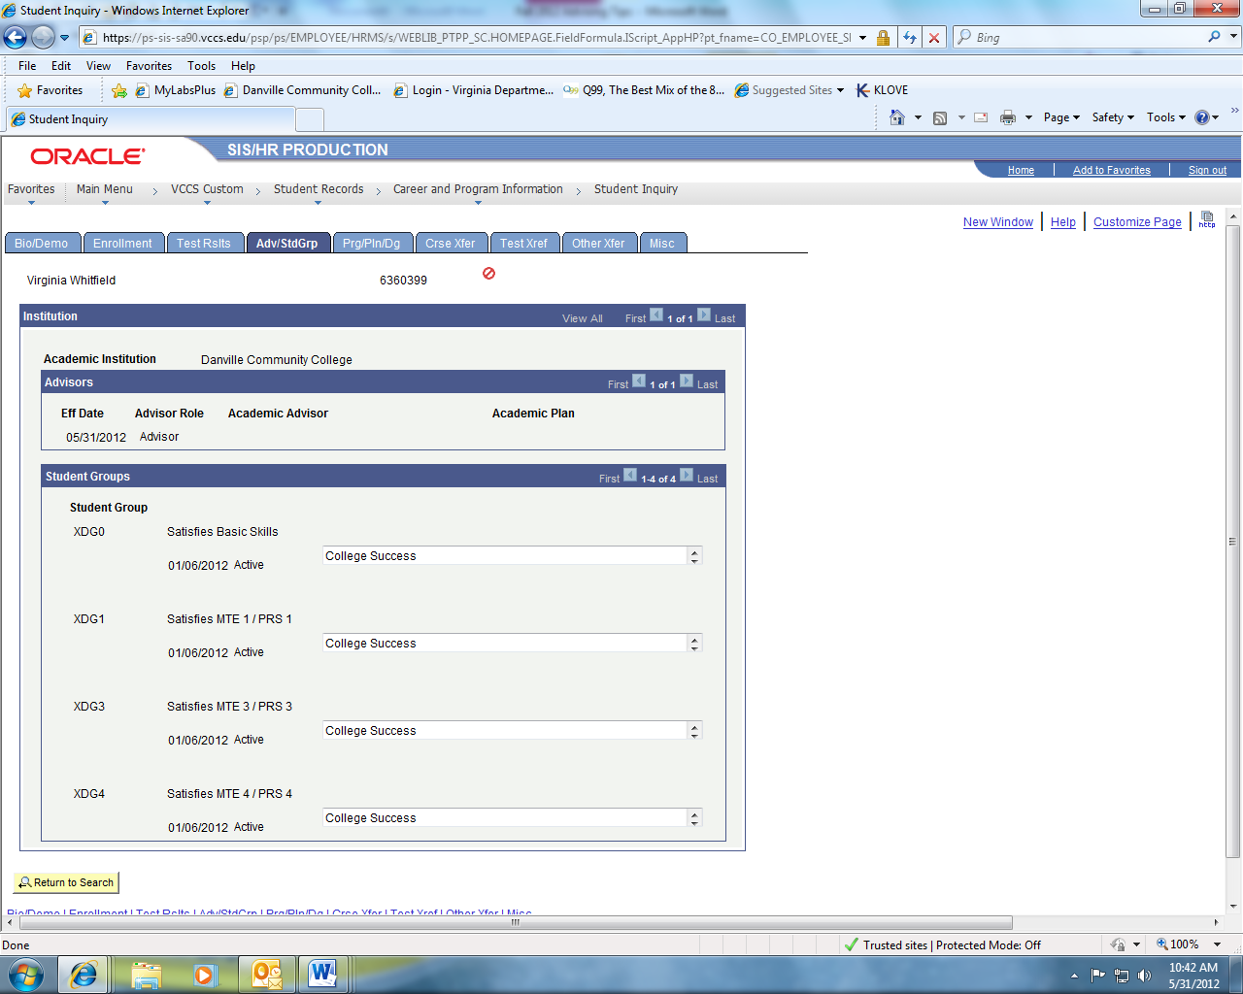
All of these were passed via the VPT,
This student satisfied Units 0, 1, 3 and 4. They will need Units 2, 5, 6, 7, 8, and 9 if required for their program of study.
Figure A: Interpreting Student Groups for Developmental Math
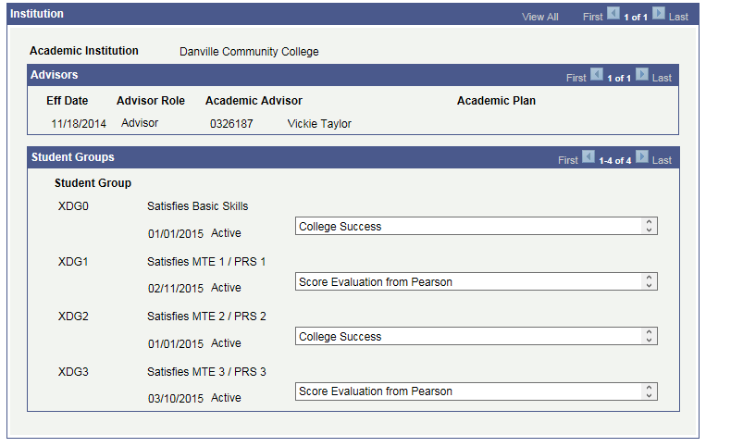
Units 0 and 2 were passed via the VPT and Units 1 and 3 were satisfied by passing the MTT course.
This student has satisfied Units 0, 1, 2, and 3 and will need Units 4, 5, 6, 7, 8, and 9 if required by their program of study.
Figure B: Interpreting Student Groups for Developmental Math

IMPORTANT: Any student that does not have “Satisfies Basic Skills” showing (Student Group XDG0) should not be registered for classes. They have placed below the floor and must talk to a counselor. These students are typically referred to Adult Ed. and/or allowed to retake the VPT upon completion of some intervention. An example of such a student is shown in Figure C.
Student has not met XDGO Satisfies Basic Skills and must be referred to a counselor.
English Placement is ENF 2.
Figure C: Identifying a Below the Floor Student in Math

STEP 3: Using information from STEP 1 and STEP 2, determine how many more math units the student must satisfy for his/her program of study. If the student needs one or two units, you will register them for one MTT 2 session. It could be session A or session B. If the student needs three or more units, you will register them for two MTT 2 sessions. This student would be in both session A and session B.
Typically you will enroll a student in the same section number. For example, you would enroll a student in MTT 2 – 01A and MTT 2 – 01B. This will ensure that the student meets with the same instructor at the same time throughout the semester. Although not common, you can enroll a student in two different section numbers provided they are not in the same session (both A’s or both B’s). For example, you could enroll a student in MTT 2 – 01A and MTT 2 – 05B. Keep in mind that changing the section number will change the time of the class and most likely the instructor of the class. You cannot enroll a student it two session A’s or two session B’s. For example, you cannot enroll a student in MTT 2 – 01A and MTT 2 – 05A. A screenshot of a course search for MTT 2 is illustrated in Figure D.
Section 06A which runs from 8/21 to 10/13.
Section 06B which runs from 10/16 to 12/08.

Figure D: Course Search for MTT 2

At a Glance
Determine how many units the student needs via Student Inquiry and sign them up for the following number of different MTT 2 classes.
1) Student Needs 1 or 2 Units: Register for one MTT 2 course
(Session A (preferable) or Session B)
2) Student Needs 3 or more Units: Register for two MTT 2 courses
(Sessions A and B)
*Try to put the student in a Session A course if possible.
*Try to keep the student in MTT 2 courses with the same section number.
*Do not put the student in two MTT 2 courses with the same session letter.

