Dear student,
Elsevier HESI Testing and your school have partnered to bring you the best, most reliable testing products available.
The link below will take you directly to the page where you will make the payment by credit card. If you are having any difficulty with the link, just follow the steps below and use the payment ID provided by your instructor.
Payment Instructions:
- Create an Evolve Account and log in
- Register for HESI
- Go to Payments
1. How to create an Evolve Account
Log into Evolve at https://evolve.elsevier.com/cs/
- Sign into your account. If you don’t have an Evolve account, you can create an account by clicking on “Sign in” and choosing “Create account” from the drop-down menu:
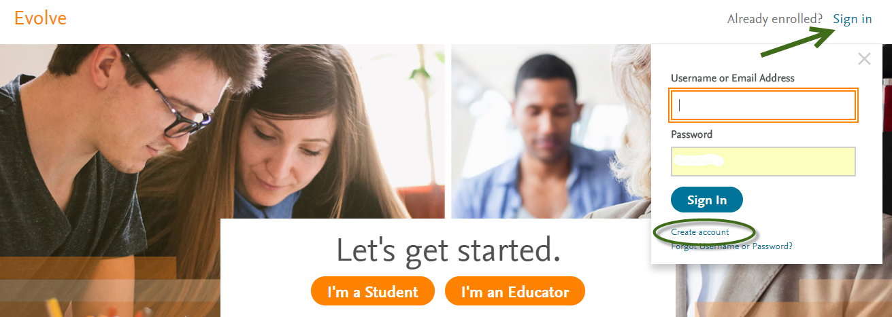Fi
- Fill in the information to set up your account. Make sure you choose “Student”. Once you have filled in the information, click on “Submit”:
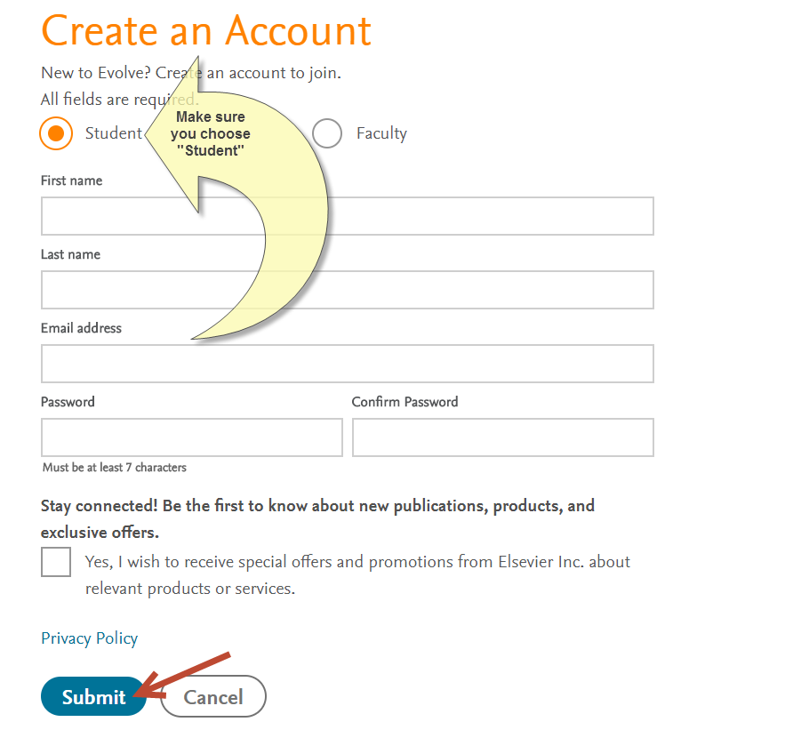
Your user name and password will be emailed to you.
2. How To Register for HESI
Under the box that says HESI Secured Exams, click on the link Register for Results and Remediation
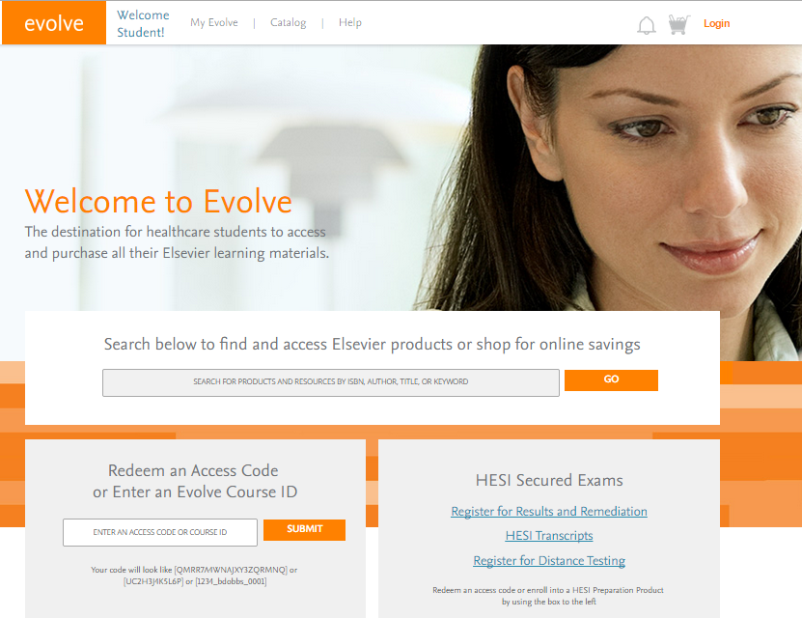
Click on the organge “register” button
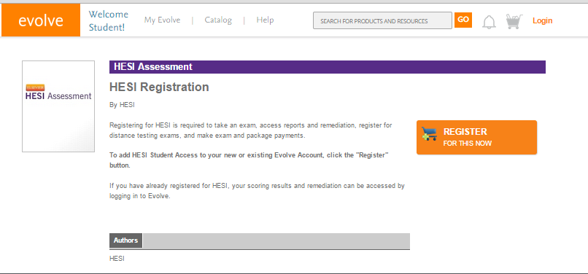
Now click on the organge “redeem checkout” button
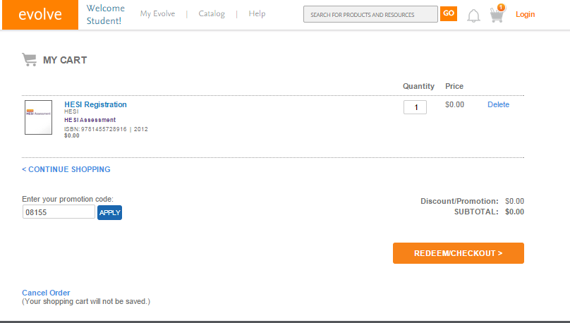

Fil in your information and click “continue”
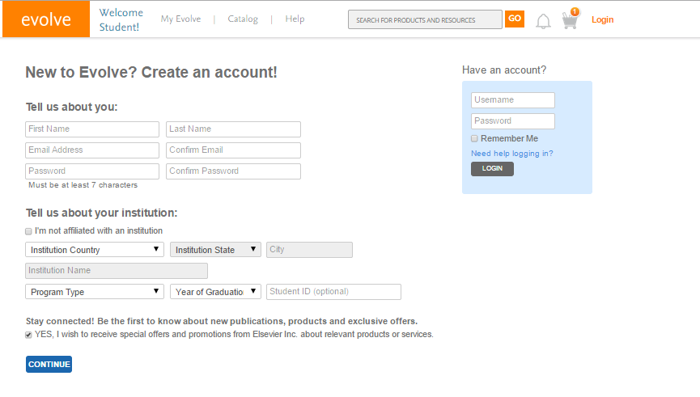
Accept the agreement by clicking on the box and then submit
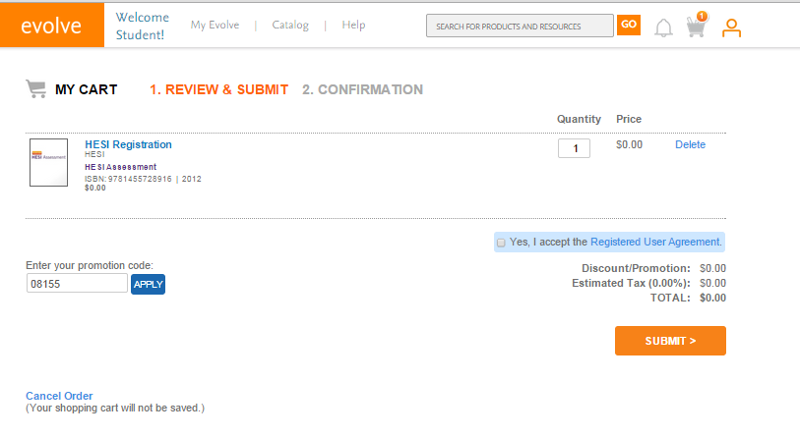

Click on the My Evolve link in the green box to go to your HESI Student Access
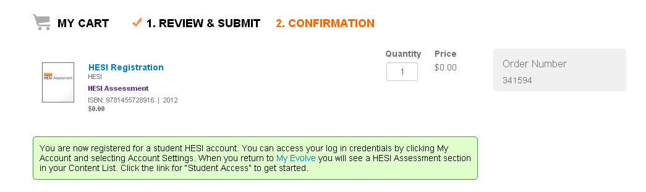
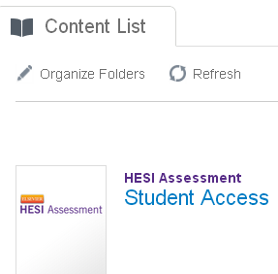

3) How to make a payment
Now you are ready to place the order. In Evolve, click on your “HESI Assessment Student Access” link:
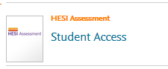
Click on the “Payments” tab and fill out the information on the Payment form below and click “proceed to checkout.” Enter Payment ID ___26895___: .
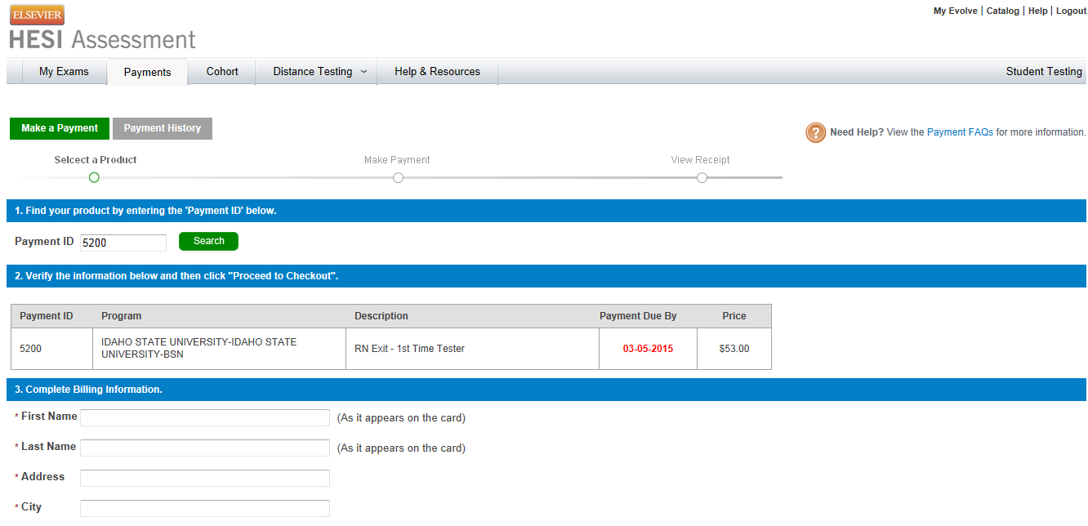

Fill out the credit card info on the screen below and you will receive a confirmation order receipt.
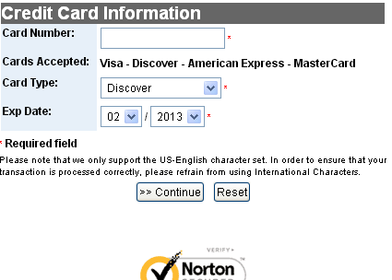
If you have any difficulty contact SUPPORT at 800 950-2728.

